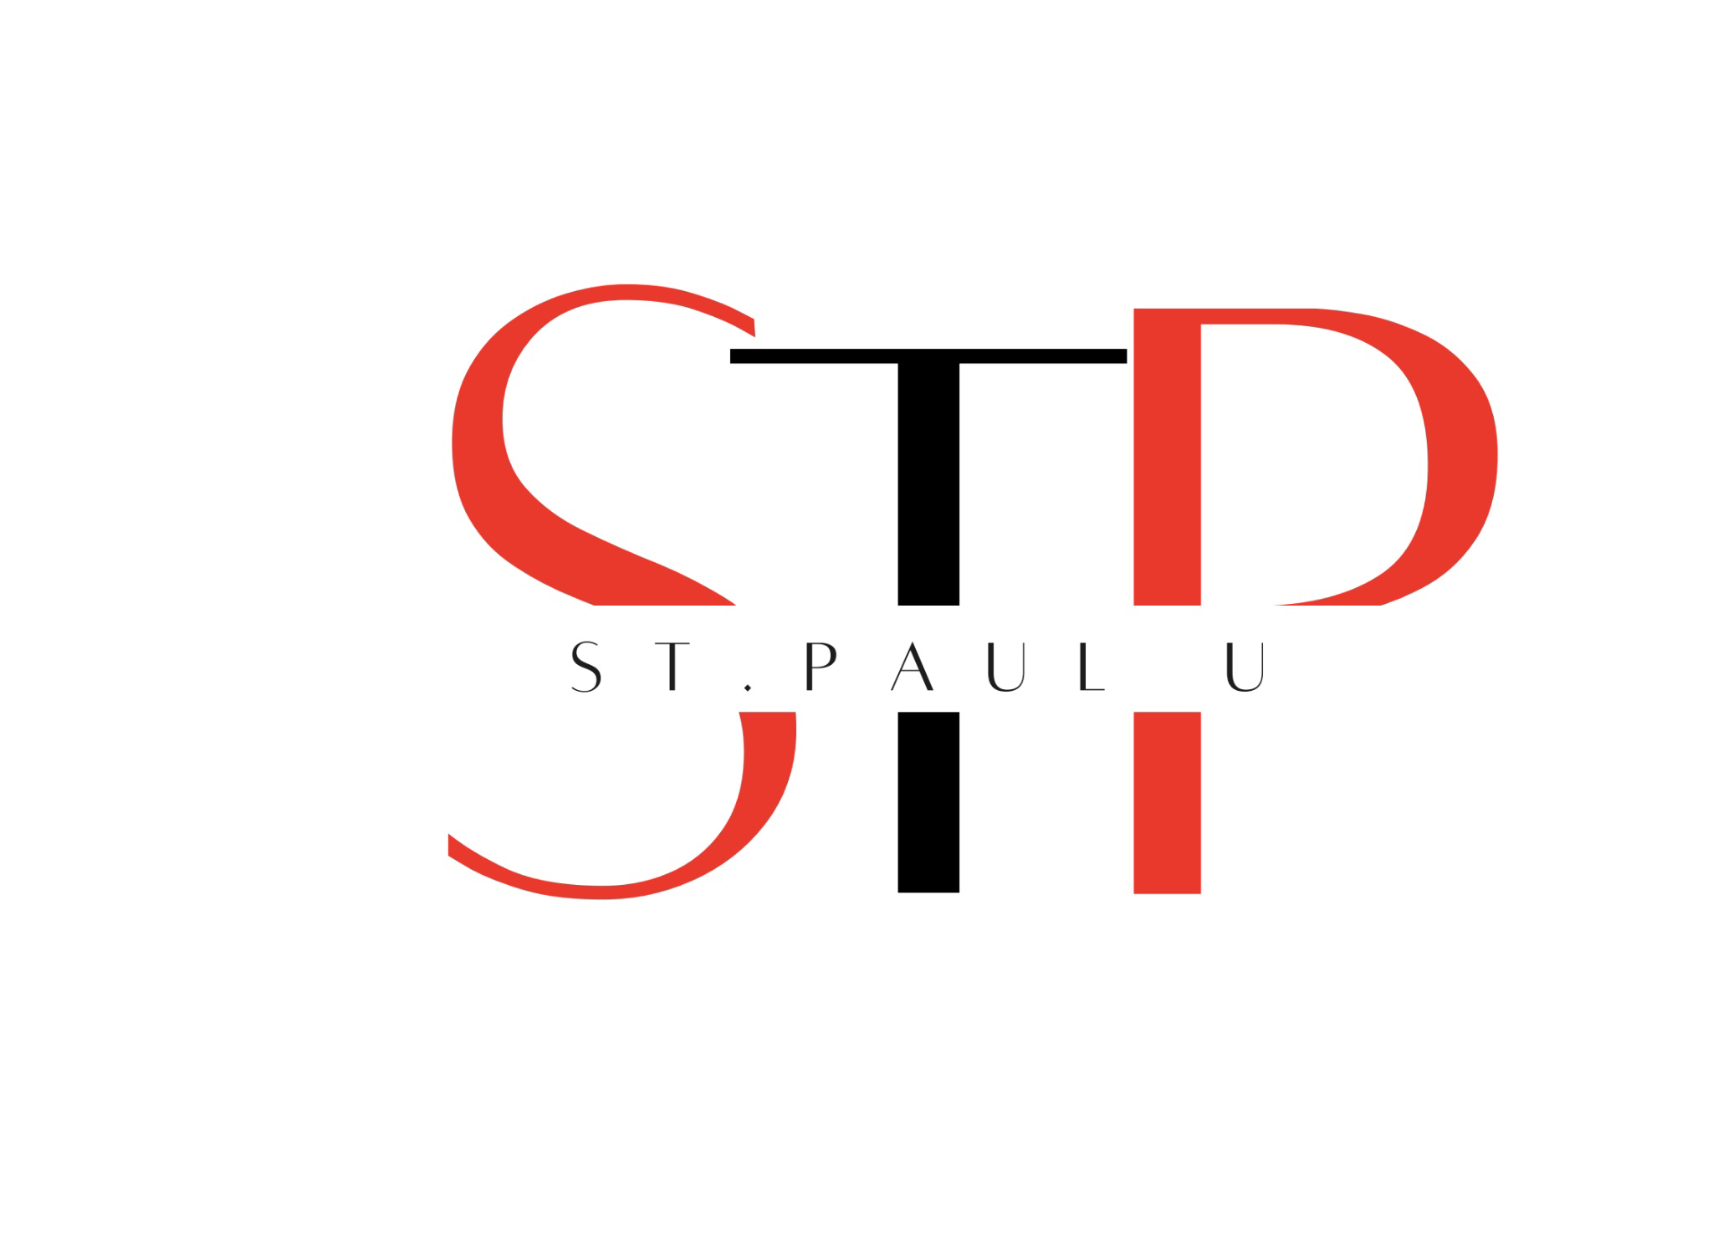
St. Paul United Methodist Church Calendar 2022
Pastors Kordell & DeNondrea Sims

January
01/9 Installation of Church Leaders
01/12,19 Leadership Training

February
02/28 Food for the Soul Meal ( Drive-Thru) 12:30 PM-2:00 PM
02/27 Black History Program 11:00 AM

March
Joint Virtual Lenten Luncheon Service (12 Noon) Via Zoom
March 9, March 16, March 23, March 30
April 6, April 13
3/2 Ash Wednesday Service
3/4 Women on Fire Paint Night
03/7-9 Spring Revival 7:00 PM
03/ 12 Leadership Round Table With Pastor Sims (Via Zoom) 6:00 PM

April
April 10-16 Holy Week
4/9 Palm Sunday
4/13 Virtual Foot Washing Service 6:00 PM
4/15 Good Friday Service ( 12: 00 Noon)
4/ 17 Resurrection Sunday (Easter ) 11:00 AM

May
05/08 (UMM) Mother’s Day Observance 11:00 AM
05/ 21 Methodist Minds with Pastor Sims (Class on the Methodism) 12:00 Noon
05/22 Baccalaureate Service & Recognition Student achievement 11:00 AM
05/29 5th Sunday Worship St. Paul UMC 11:00 AM

June
6/19 (UMW) Father’s Day Observance

July
7/5-9 Discipleship Week (Via zoom)
7/13-15 MS Annual Conference
7/25 Pastor Sims’ 3rd year Pastoral Anniversary (11:00AM)
5th Sunday Worship (St. Paul) 11:00 am

August
8/6 Distribution of school supplies/Blessings of Backpack 11:00 AM
8/2 Pastor D Birthday
8/13 Taste of the Season Program
8/ 24 Leadership Round Table With Pastor Sims (Via Zoom) 6:00 PM

September
9/10 Taste of the Season Program
9/11 Grandparents Day
9/18 Pew Rally Program 11:00
9/24 Methodist Minds with Pastor Sims (Class on the Methodism)
9/29 Pastor Kordell Sims Birthday 36th

October
- Pastor Appreciation Month/Breast Cancer & Domestic Violence Awareness Month
10/23 Family and Friends Day 3:00 PM
10/25-27 Fall Revival 7:00 PM Nightly
10/30 159th Church Anniversary
10/31 Trunk or Treat (5:30 PM-7:00PM)

November
- Local church Leadership Appreciation Month

December
12/24 Christmas Eve Service 7 PM

Notes to Remember
*Food Pantries Wednesday’s & Friday’s Noon -2:00 PM
Feeding GulfCoast (TBA)

